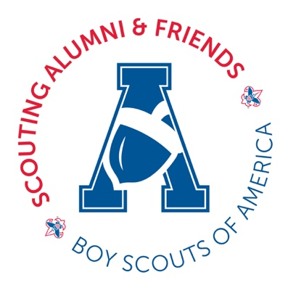
SCOUTING SERVICE COMMEMORATION

The following suggested ceremonies were designed for the presentation of this Scouting Service Commemoration. These scripts are easy for event organizers to use or adapt depending upon local circumstances. Ceremonies can be performed at a standalone event, a district or council recognition event, as part of an Order of the Arrow, Wood Badge, Camp Association event or at a unit Court of Honor or special meeting. Recipients should be consulted as to the type of event preferred.
Ceremony #1 – Local Event
Designed for a District Committee, District Recognition, Roundtable,
Affiliate event or Unit Court of Honor

District Executive or District Committee Chair or District Commissioner:
- Today (this evening/this morning) we are celebrating the service that RECIPIENT has provided to Scouting over the past (25-50-75) years. RECIPIENT began his Scouting career in _______ in ______ Council and it continues to this day. This is a very important milestone in the Scouting Movement, as his (her) service has impacted countless youth and their communities in so many ways.
- It is a distinct honor and privilege that we acknowledge (25-50-75) years of service.

- Will RECIPIENT please come forward? (RECIPIENT is escorted with spouse. Immediate family may also come forward.)

- RECIPIENT’S designated person makes the presentation of the award, framed certificate and lapel pin.

- RECIPIENT’S spouse pins lapel pin onto the RECIPIENT.

- RECIPIENT’S spouse is presented with a token of the council’s esteem (flowers, chocolates, etc.)

- RECIPIENT’S Response: “I want to thank…”

- Ceremony is concluded
Ceremony #2 – Council Event
Designed for a Council Executive Board Meeting, Council Recognition Ceremony
or as a Stand-Alone Event

Council Executive, Council President or Council Commissioner:
- Call to Order

- Presentation of the Colors & Pledge of Allegiance

- Welcome & Introduction of Honored guests – emcee

- Invocation – Scouter or clergy

- Opening of the Court of Honor – “On behalf of the National Council of the Boy Scouts of America, I hereby convene this Court of Honor for the purpose of presenting the Scouting Service Commemoration to RECIPIENT(S). Will the following RECIPIENT(S) please come forward?”

- The Scouting biography of each recipient. (Starting with youth membership, ranks earned and Scouter positions held.)

- RECIPIENT’S designated person makes the presentation of the award, framed certificate and lapel pin.

- Spouse pins lapel pin onto RECIPIENT.

- RECIPIENT’S spouse is presented with a token of the council’s esteem (flowers, chocolates, etc.)

- RECIPIENT’S Response: “I want to thank…”

- Scout Vespers & Scoutmaster’s Benediction

- Ceremony is concluded

- Reception: This optional element varies from snacks or dessert and non-alcoholic beverages to something resembling a wedding reception.

